<https://www.youtube.com/watch?v=dnGeRjP8oxw>

# Master File

## Put a File in Git Hub for the First Time

1. Go to the Command Prompt and type where python (This is the Path)

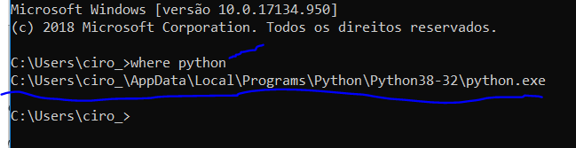

1. Download Git:

<https://git-scm.com/download/win>

If you need follow the steps of the video below

<https://www.youtube.com/watch?v=nbFwejIsHlY>

**MAKE SURE TO DOWNLOAD THE GIT IN THE SAME PATH WHERE THE PYTHON IS**

1. Go to Git Hub:

<https://github.com/>

1. Click Start Project

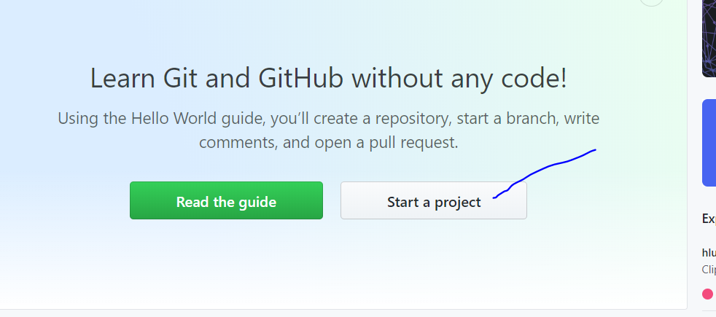

1. Create a name, Public, Read Me and then create

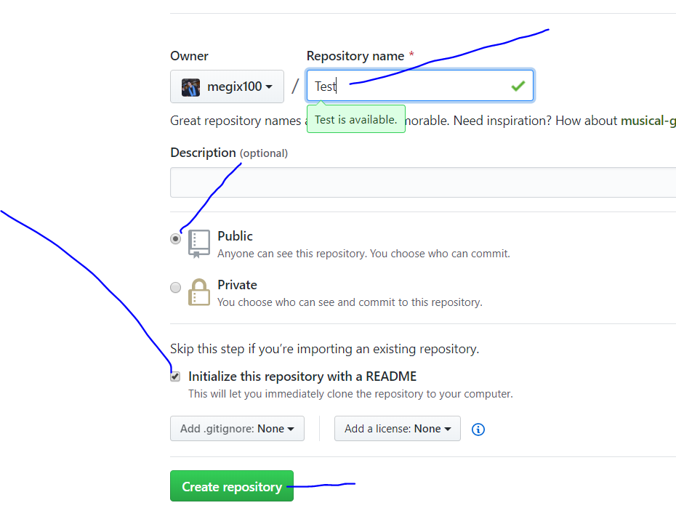

1. Go to Clone or Download, make sure it is HTTPS, copy

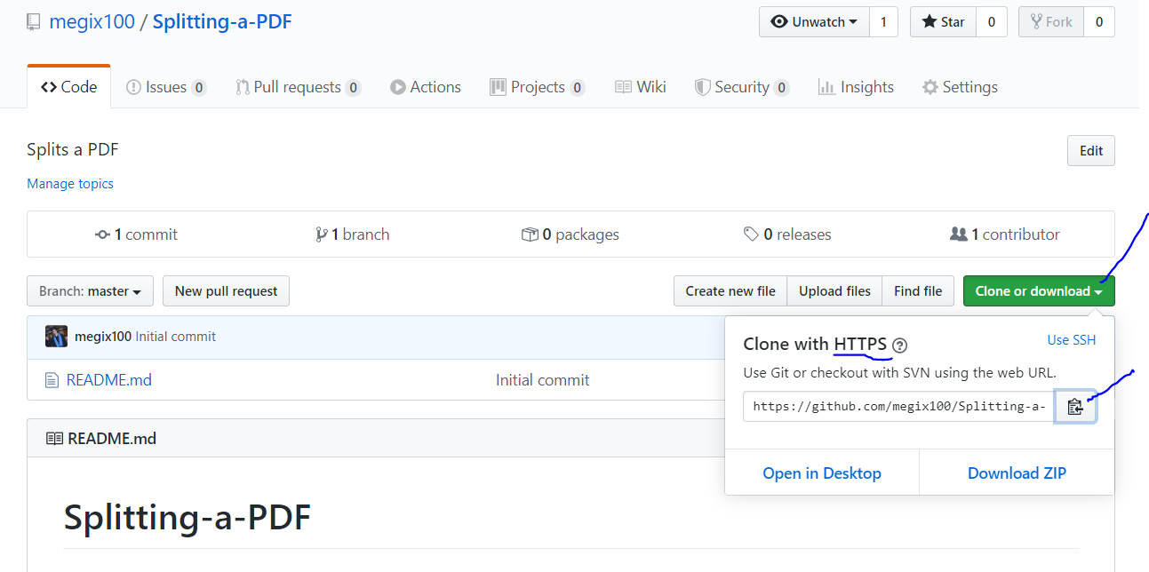

1. Go to the Windows Power Shell
2. Go to the file folder you want to put in git hub is. After you have the path you can type in the Windows Power Shell:

cd "D:\CIRO (Estudos Compactados)\CENTENNIAL\CENTENNIAL (ENERGY ENGINEERING)\Matérias\Python\Git Hub"

1. Type:

git clone PASTE LINK FROM GIT HUB



1. You should have another folder there:

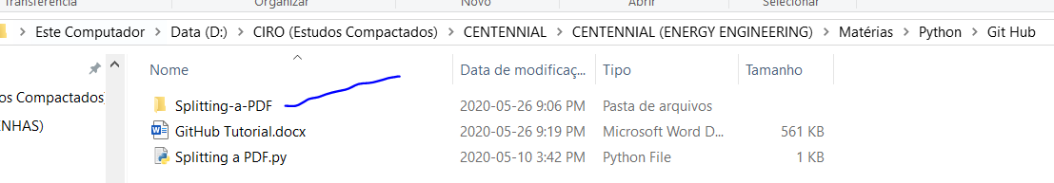

1. Get the file you want and paste inside this folder

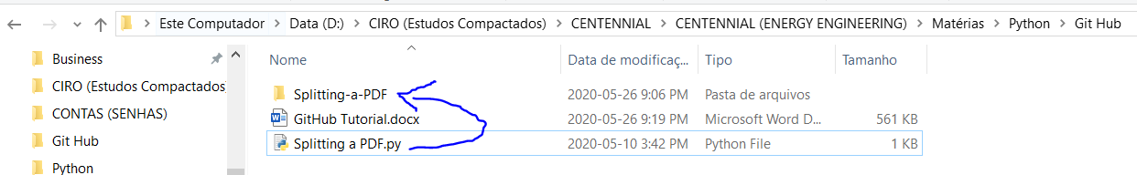

1. Go inside the project in the Windows Power Shell:

cd NAME OF THE FOLDER CREATED/



1. You can type ls to check all your files and your file should be inside there

ls

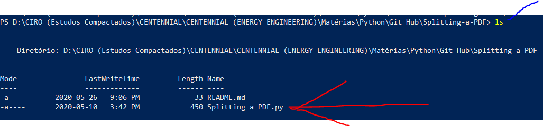

1. Type in Windows Power Shell:

git status

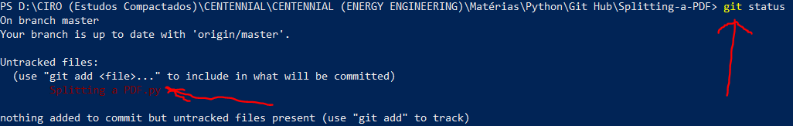

1. Type in Windows Power Shell:

git add NAME OF THE FILE



THE FILE CAN’T HAVE SPACES

IF YOU HAVE MULTIPLE FILES YOU WANT TO PUT IN GIT HUB, TYPE: git add .

1. Type in Windows Power Shell:

git status

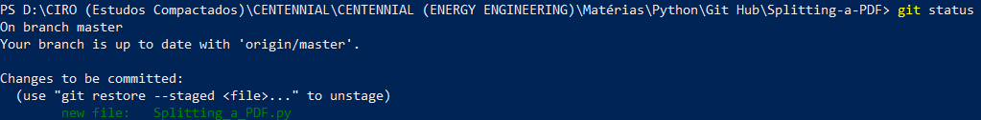

1. Type in Windows Power Shell:

You will need to use your USERNAME and E-MAIL from Git Hub

git config user.name “USERNAME”

git config user.email “E-MAIL”



1. Type in Windows Power Shell:

git commit -m "BRIEF MESSAGE"

1. Type in Windows Power Shell:

git push

1. Put your login

## Put a file in Git Hub (after the repository has been created) from your desktop

1. Get the file you want and paste inside this folder



1. Type in Windows Power Shell:

git status



1. Type in Windows Power Shell:

git add NAME OF THE FILE



THE FILE CAN’T HAVE SPACES

IF YOU HAVE MULTIPLE FILES YOU WANT TO PUT IN GIT HUB, TYPE: git add .

1. Type in Windows Power Shell:

git status



1. Type in Windows Power Shell:

git commit -m "BRIEF MESSAGE"

1. Type in Windows Power Shell:

git push origin HEAD:master

## Put a File in Git Hub (after the repository has been created) from the Branch

1. Go to the Branch Folder Type in Windows Power Shell:

git checkout master



1. Type in Windows Power Shell:

git merge NAME OF THE BRANCH



1. Type in Windows Power Shell:

git push origin master



## Download a File from Git Hub

1. Go to the Command Prompt and type where python (This is the Path)



1. Download Git:

<https://git-scm.com/download/win>

If you need follow the steps of the video below

<https://www.youtube.com/watch?v=nbFwejIsHlY>

**MAKE SURE TO DOWNLOAD THE GIT IN THE SAME PATH WHERE THE PYTHON IS**

1. Go to Git Hub:

<https://github.com/>

1. Go to Clone or Download, make sure it is HTTPS, copy



1. Go to the Windows Power Shell
2. Go to the file folder you want to put in git hub is. After you have the path you can type in the Windows Power Shell:

cd "D:\CIRO (Estudos Compactados)\CENTENNIAL\CENTENNIAL (ENERGY ENGINEERING)\Matérias\Python\Git Hub"

1. Type:

git clone PASTE LINK FROM GIT HUB



## After somebody changed the file while you were editing (GETTING THE MOST RECENT VERSION)

1. Type in Windows Power Shell

git pull

# Branch

## Creating a branch

1. After having the most updated file. It is recommended to not work in the master, but in a Test version that is called Branch.
2. To create a Branch Type in Windows Power Shell:

git branch NAME OF THE BRANCH



1. Check if the branch was created Type in Windows Power Shell:

git branch



1. Go to the Branch Folder Type in Windows Power Shell:

git checkout NAME OF THE BRANCH



## Copying everything from the master to the Branch

1. Go to the Branch Folder Type in Windows Power Shell:

git checkout NAME OF THE BRANCH

1. Type in Windows Power Shell:

git merge master

## Putting a File in the Branch

1. Go to the Branch Folder Type in Windows Power Shell:

git checkout NAME OF THE BRANCH



1. Type in Windows Power Shell:

git push origin NAME OF THE BRANCH



1. Type in Windows Power Shell:

git status



1. Type in Windows Power Shell:

git add NAME OF THE FILE



THE FILE CAN’T HAVE SPACES

IF YOU HAVE MULTIPLE FILES YOU WANT TO PUT IN GIT HUB, TYPE: git add .

1. Type in Windows Power Shell:

git status



1. Type in Windows Power Shell:

git commit -m "BRIEF MESSAGE"

1. Type in Windows Power Shell:

git push origin HEAD

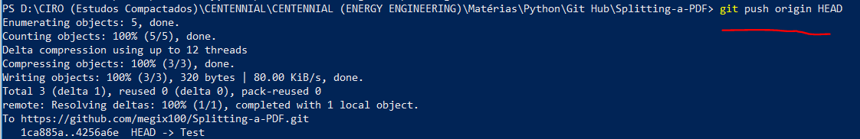

## Downloading a from the Branch

## Delete a Branch

git branch -D NAME OF THE BRANCH